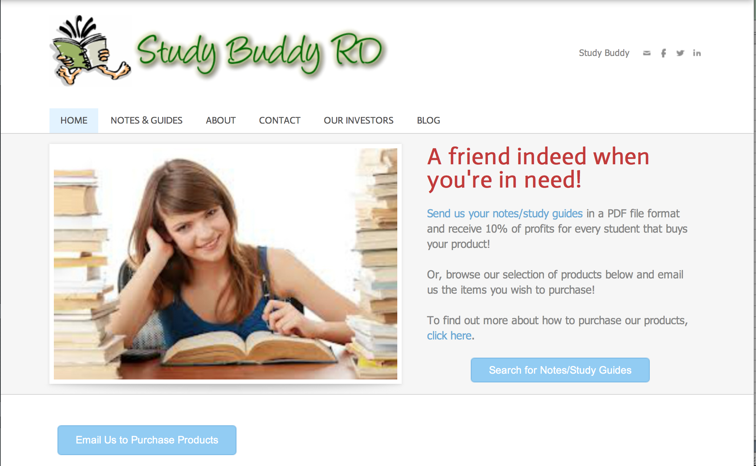

**What is Study Buddy?**

Study Buddy is a tool for students, **managed by students**, which provides a **safe and user-friendly** venue through which students can buy and sell their **class notes and study guides**. It allows them to make use of the work they have put into their studies over the years, as well as help other students in doing so.

Its main products are notes and study guides, available for **every grade and class subject**, ranging from retail prices of $5 to $30.

**Why should YOU invest in Study Buddy?**

Over the years, the idea of providing online high school student resources has become more and more popular, with websites such as Sparknotes, Cliff Notes, or GradeSaver gaining notoriety.

Study Buddy, however, is **entirely student run**, giving students the chance to reach academic excellence independently. Through this, students learn the value of responsibility, instilling in them habits that will help them far beyond their high school years.

**Study Buddy RD**

The Community for Learning  
Santo Domingo, Dominican Republic

studybuddyrd.weebly.com

(809) 563-2708

Study Buddy RD

“Our team has been working together since the founding of Study Buddy in 1984, and we have dedicated ourselves to making the Study Buddy experience efficient and useful. Our three incredible web designers update our website on a weekly basis to make sure all of our customers are satisfied. The process of buying and selling notes is user-friendly, and anyone can easily contact us for assistance. We have sold over 5,000 notes and guides to nearly 1,000 Community for Learning students, and we are now looking to expand and offer our services to other schools in the Dominican Republic. We hope to someday help students on a global level, but we can only achieve this with the help of our investors.”

**-Study Buddy Board of Directors**

#### Curabitur felis nisi, vehicula eu, bibendum id, erat.

Aliquam erat volutpat. Donec urna. Vestibulum vehicula. Nam vitae ligula eu dui tristique elementum. Pellentesque volutpat, nunc id venenatis molestie, dolor ligula ultrices orci, quis rhoncus est libero volutpat lorem. Nulla nonummy viverra augue. Aliquam mauris pede, gravida a, adipiscing ac, accumsan nec, odio. Integer neque. Nulla aliquet justo sit amet odio. Ut pulvinar est ac risus. Donec a sem vitae nisl placerat pulvinar.

#### Nulla eleifend dolor vel tellus.

Duis id nisl vitae pede vulputate porttitor. Vivamus rhoncus, velit vitae consequat gravida, lacus massa vulputate nisl, id rutrum sem massa non sapien. Morbi vel enim ac lacus lobortis nonummy. Proin tempor. Cum sociis natoque penatibus et magnis dis parturient montes, nascetur ridiculus mus. Nam facilisis erat vitae ligula. Etiam nec felis et neque condimentum aliquet.

**Amount of Shares Available:**

**7,000 shares**

**If you are interested in investing, please contact Study Buddy’s underwriter, J.P. Morgan Chase**

**How will Study Buddy protect your investment?**

* Study Buddy employees are legally bound to keep confidential any personal information disclosed by our investors.
* Investors are permitted to withdraw up to 60% of their initial investment if, within a 2-week period after the date of their purchase, they are dissatisfied with the Company.
* Study Buddy has employed insurance policies to protect the company in the case of economic or natural disasters.

|  |  |  |  |  |
| --- | --- | --- | --- | --- |
| **Cost of 1 Share (IPO)** | **Market Capitalization** | **Average Return on Investment** | **Least Possible Investment** | **Greatest Possible Investment** |
| $25 | 1.59 M | 0.65% | 20 shares | 1,000 shares |

**Investing in Study Buddy**

**News Update!**

Recent surveys have shown that companies providing summarization resources for high school students are in high demand. Industry analysts predict that these companies will perform handsomely for the foreseeable future.

We have received 21 investors and over US$76,000 worth of investments

Our share value has increased by 1.37% (13.3 points)

Our Capital Value (Market Capitalization) has increased by US$450,000

**This Quarter’s progress**